BÁO CÁO THỰC HÀNH LAB 2  
LẬP TRÌNH HƯỚNG ĐỐI TƯỢNG

# Problem Modeling and Encapsulation

## *3. Use case diagram*:

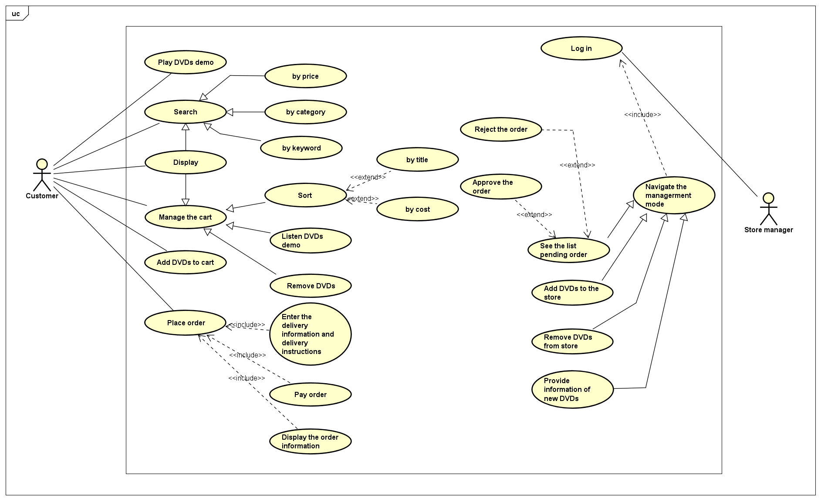

## 4. UML Class Diagram for use cases related to cart management

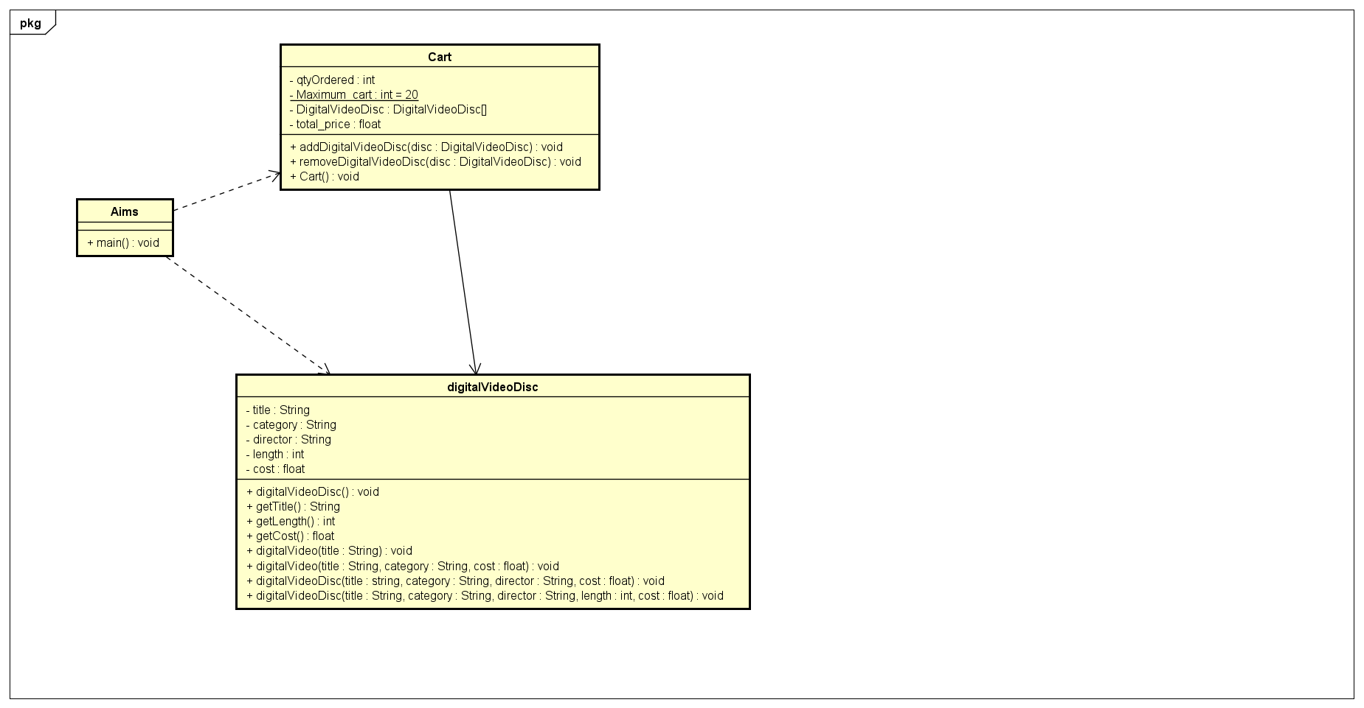

## 5. Create Aims class

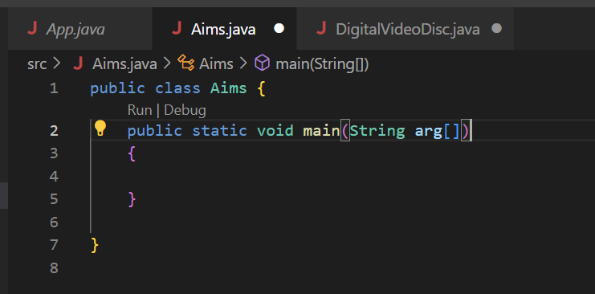

## 6. Create the DigitalVideoDisc class and its attributes

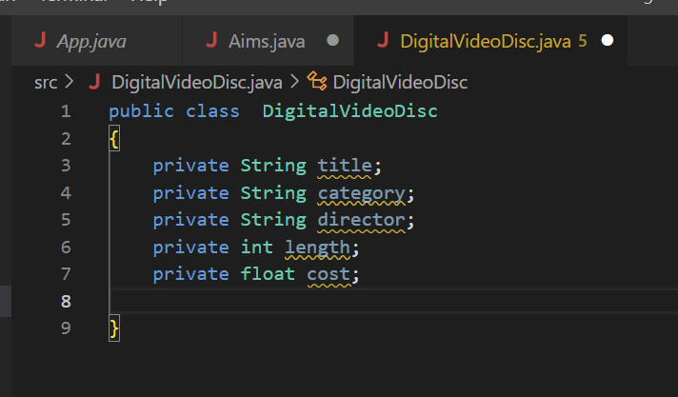

## 7. Create accessors and mutators for the class DigitalVideoDisc

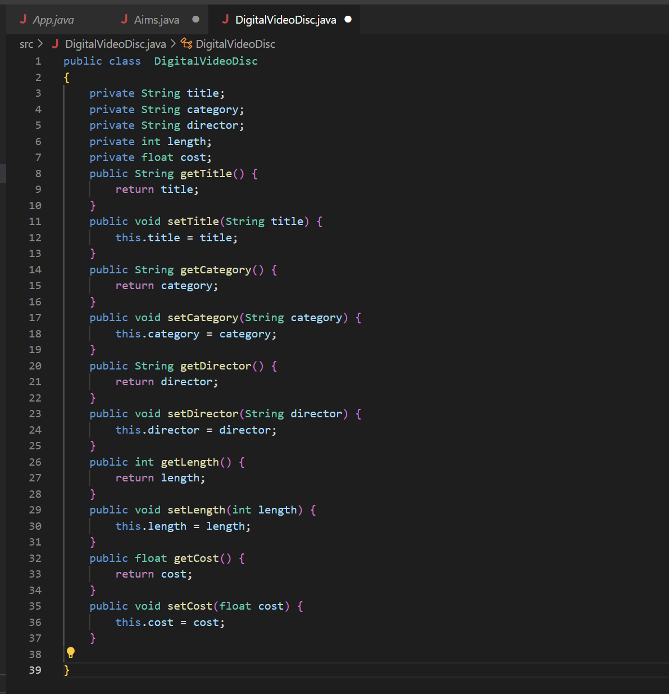

**Reading Assignment:**

Accessor methods should be used in Java when we want to enforce encapsulation and ensure that the internal state of an object is only accessed and modified in a controlled manner.

By using accessor methods, we can hide the implementation details of the object from other classes, which makes it easier to maintain and modify the code without affecting other parts of the system.

Additionally, accessor methods can be used to add additional functionality, such as validation or synchronization, when accessing or modifying the object's state.

## 8. Create Constructor method

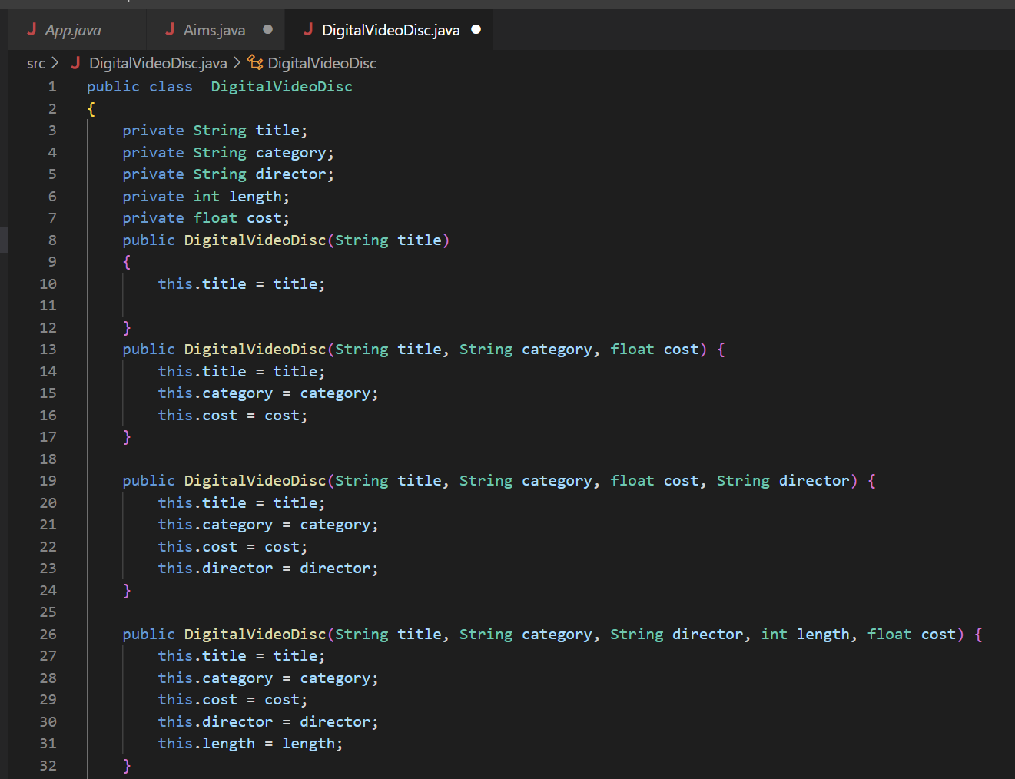

## 9. Create the Cart class to work with DigitalVideoDisc

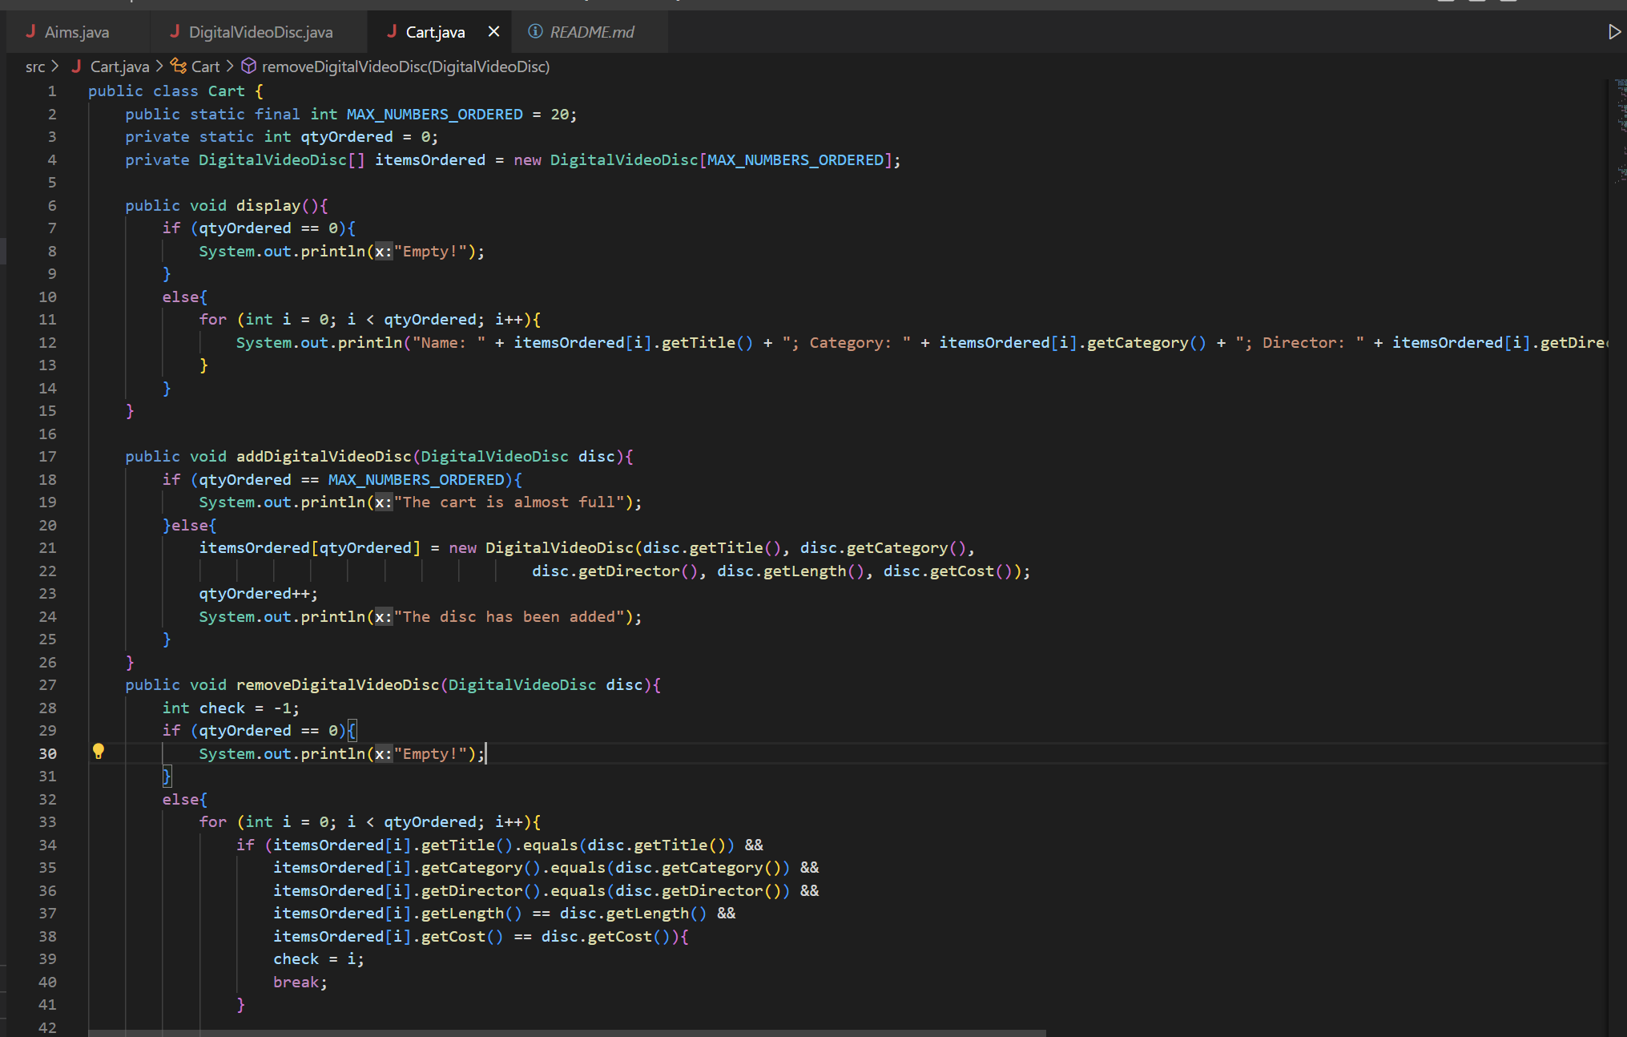

## 10.Create Carts of DigitalVideoDiscs

### 

### Result:

### 

## 11.Removing items from the cart

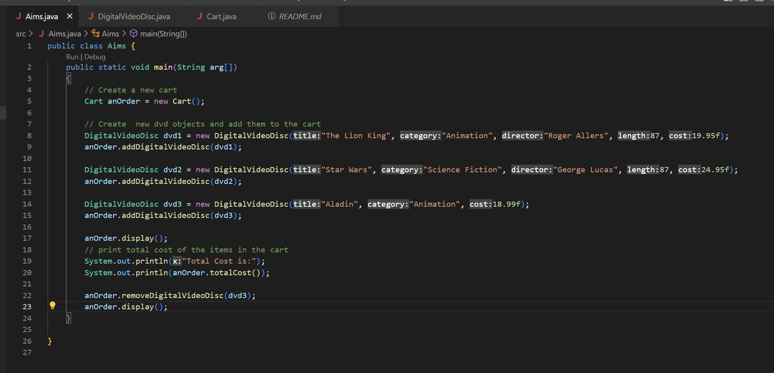

Result:

